**SQL ASSIGNMENTS**

Create a database worker that should contain **first name, last name email, department, salary, Join Date** with 50 employees.

**Task-1**

1. Write an SQL query to fetch “FIRST_NAME” from the Worker table using the alias name as <WORKER_NAME>.

Ans. Select FIRSTNAME AS WORKERNAME from employee;

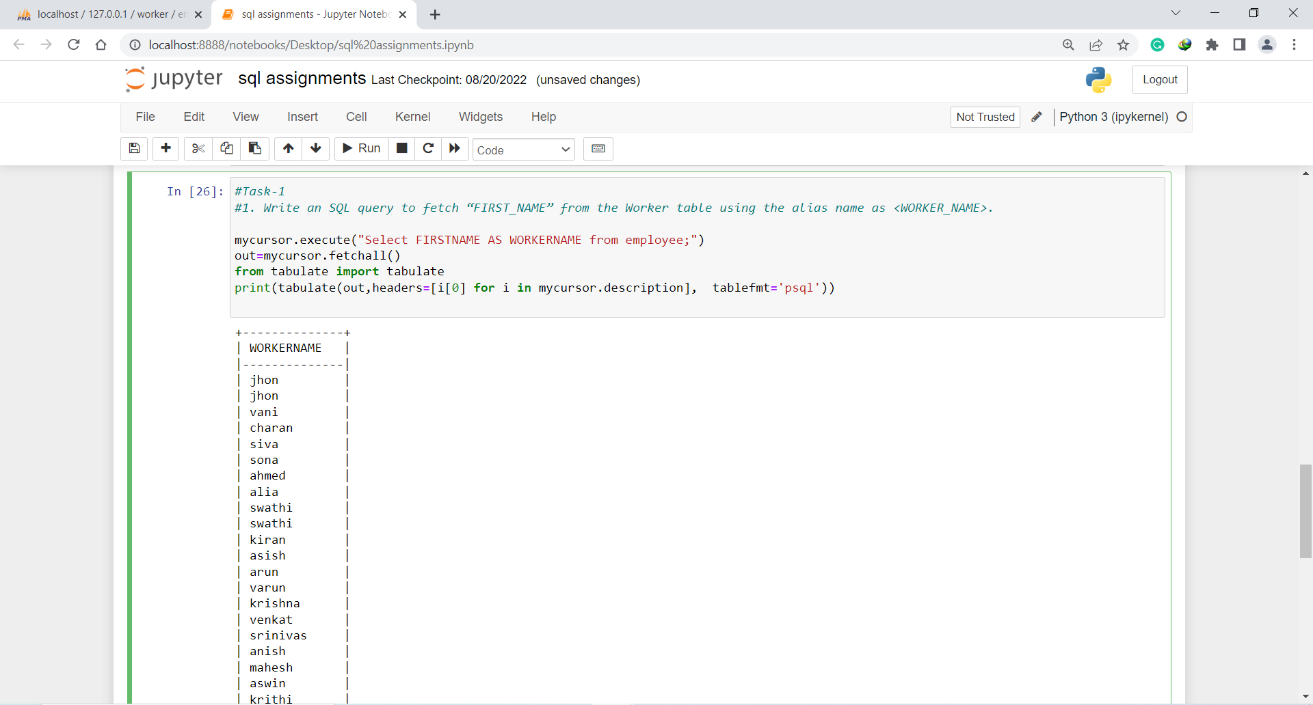

1. Write an SQL query to fetch unique values of DEPARTMENT from the Worker table.

Ans. Select distinct DEPARTMENT from employee;

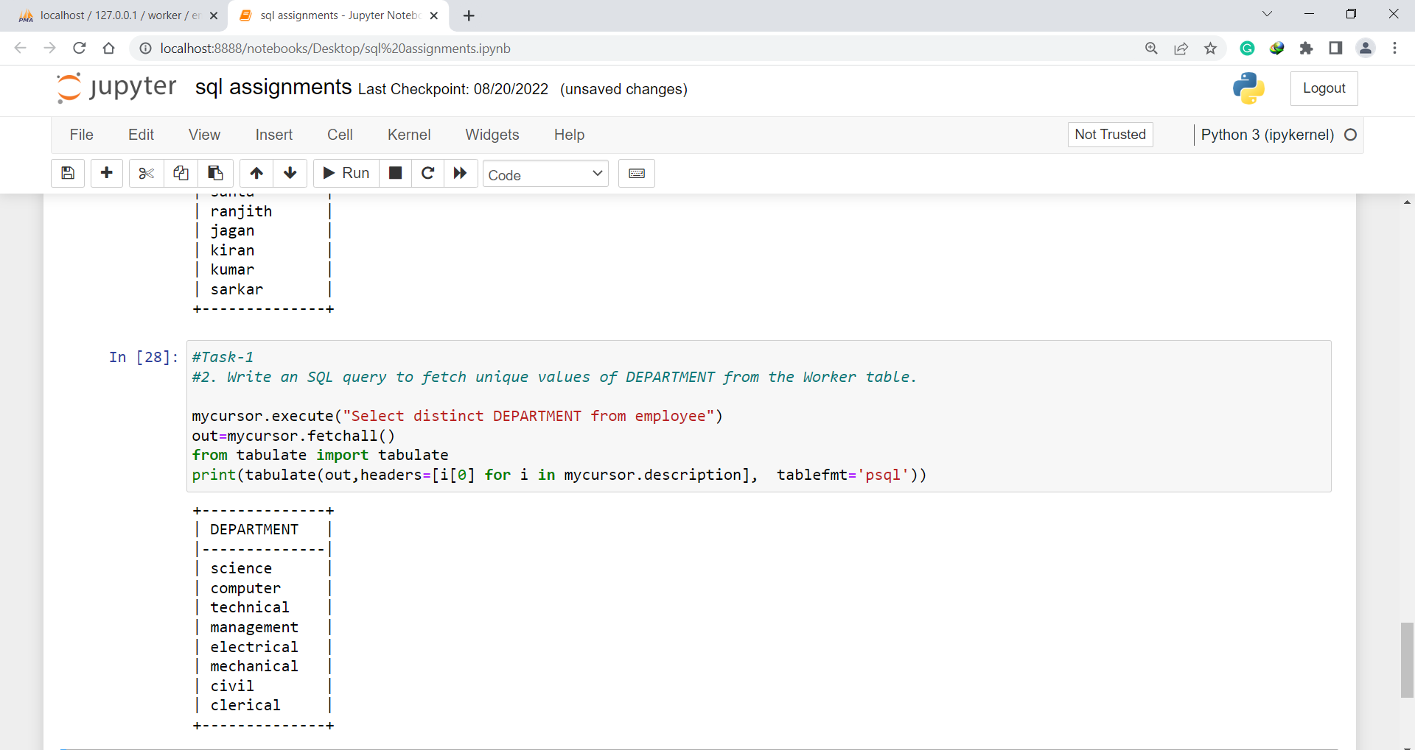

1. Write an SQL query to show the last 5 records from a table.

Ans. SELECT * FROM employee ORDER BY sno desc limit 5;

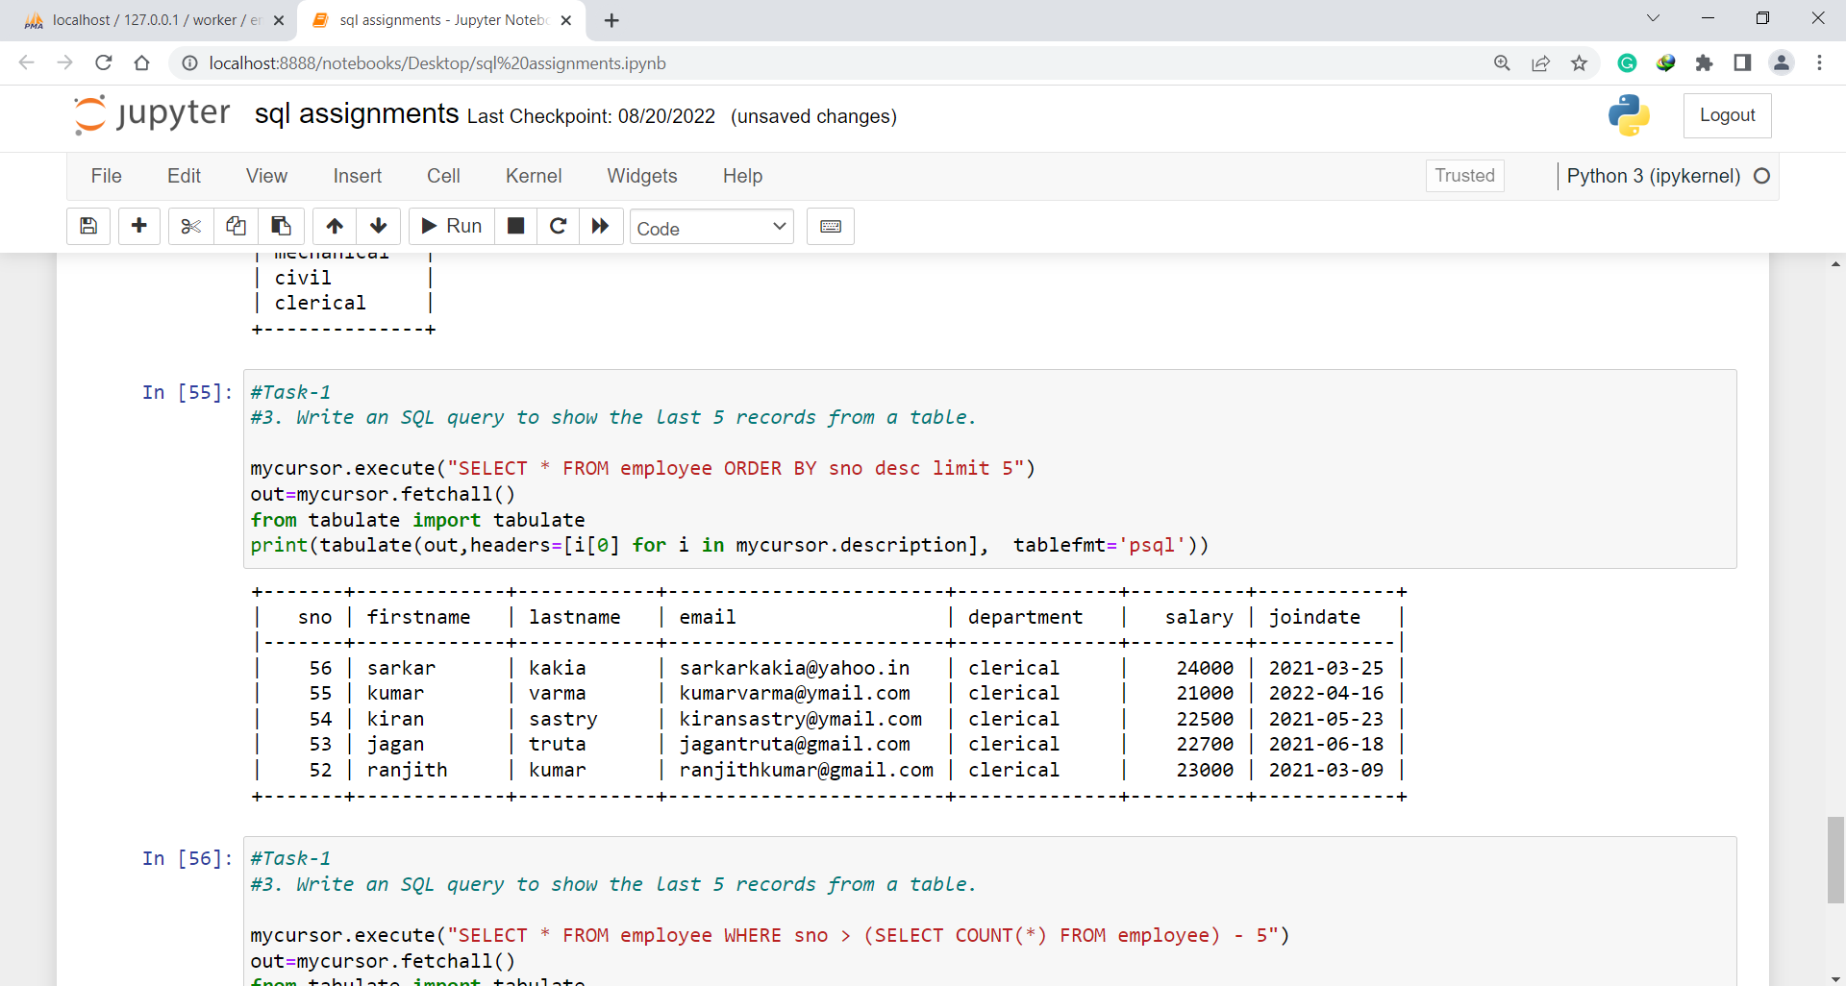

**Task-2**

1. Write an SQL query to print the first three characters of FIRST_NAME from Worker

Ans. Select substring(FIRSTNAME,1,3) from employee.

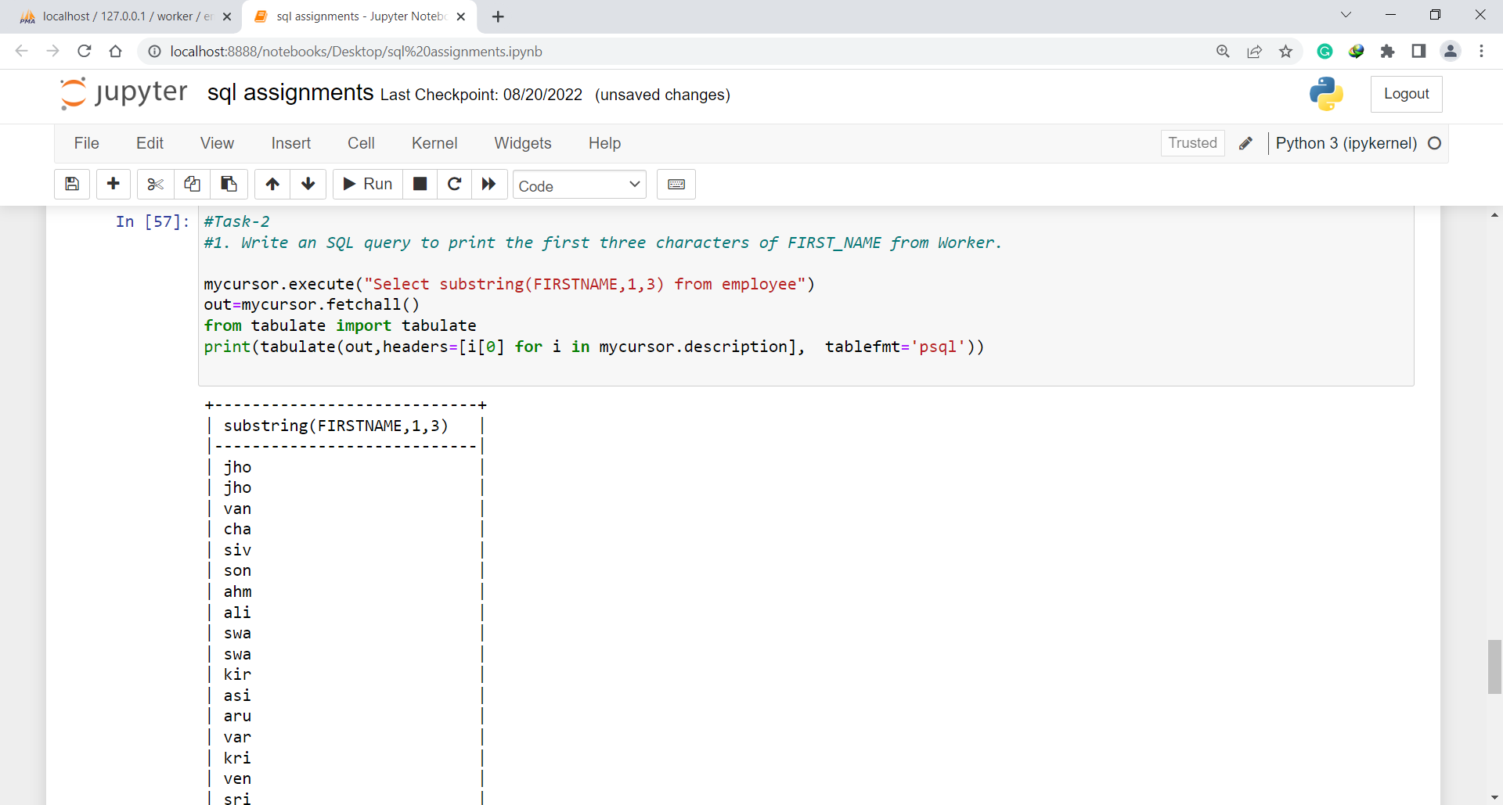

1. Write an SQL query to find the position of the alphabet (‘a’) in the first name

Ans. SELECT firstname, POSITION('a' in firstname) FROM employee;

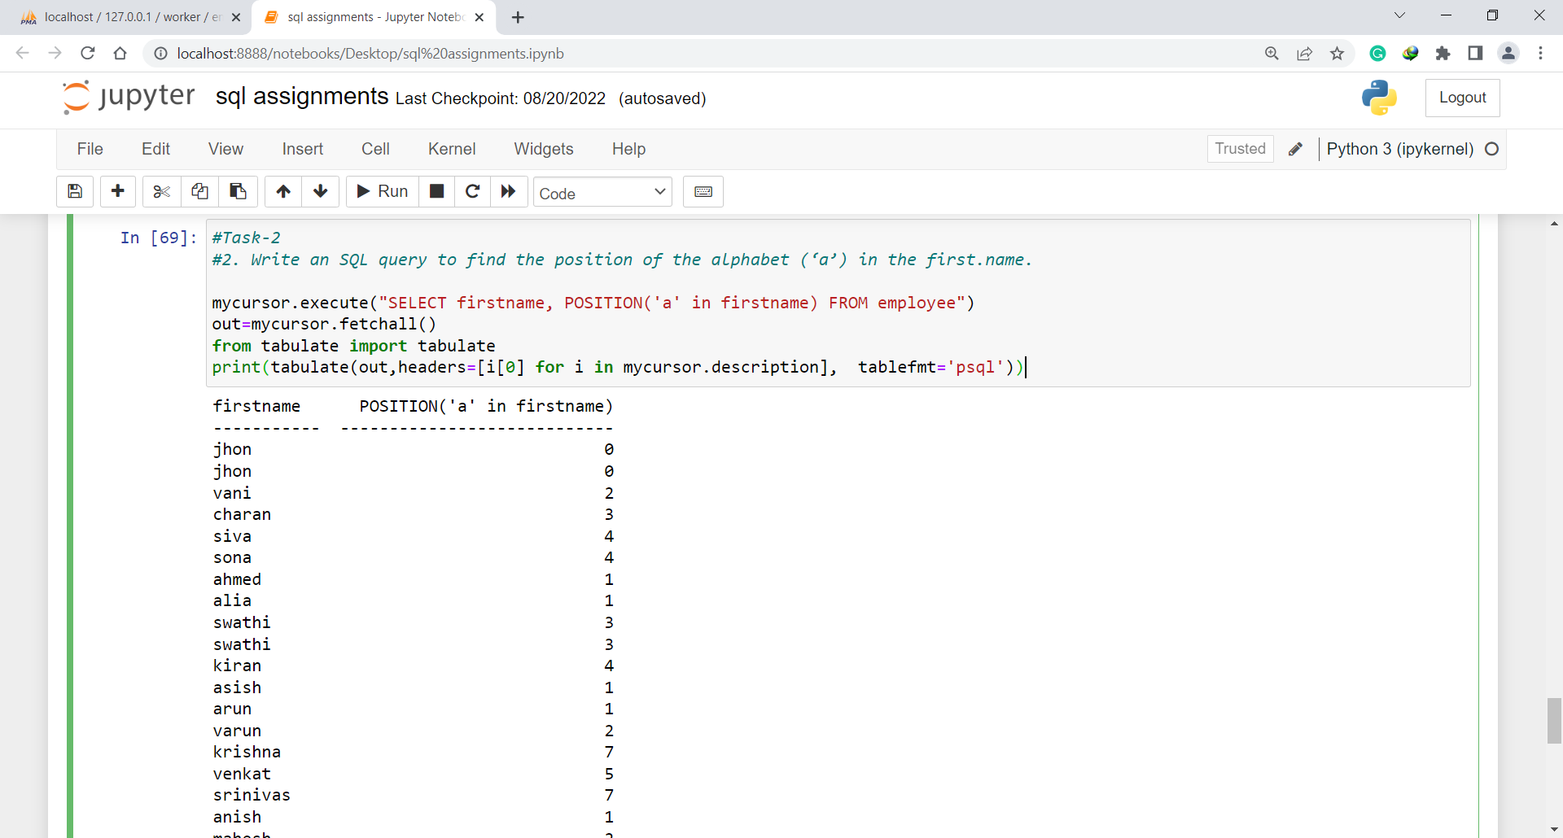

1. Write an SQL query to print the name of employees who have the highest salary in each department.

Ans. SELECT firstname,Department, MAX(Salary) FROM Employee GROUP BY Department;

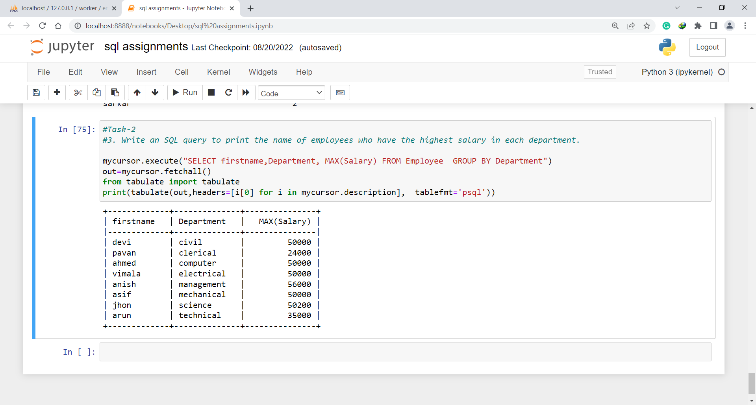

**Task-3**

1. Write an SQL query to print the FIRST_NAME from the Worker table after removing white spaces from the right side.

Ans. Select RTRIM(firstname) from employee;

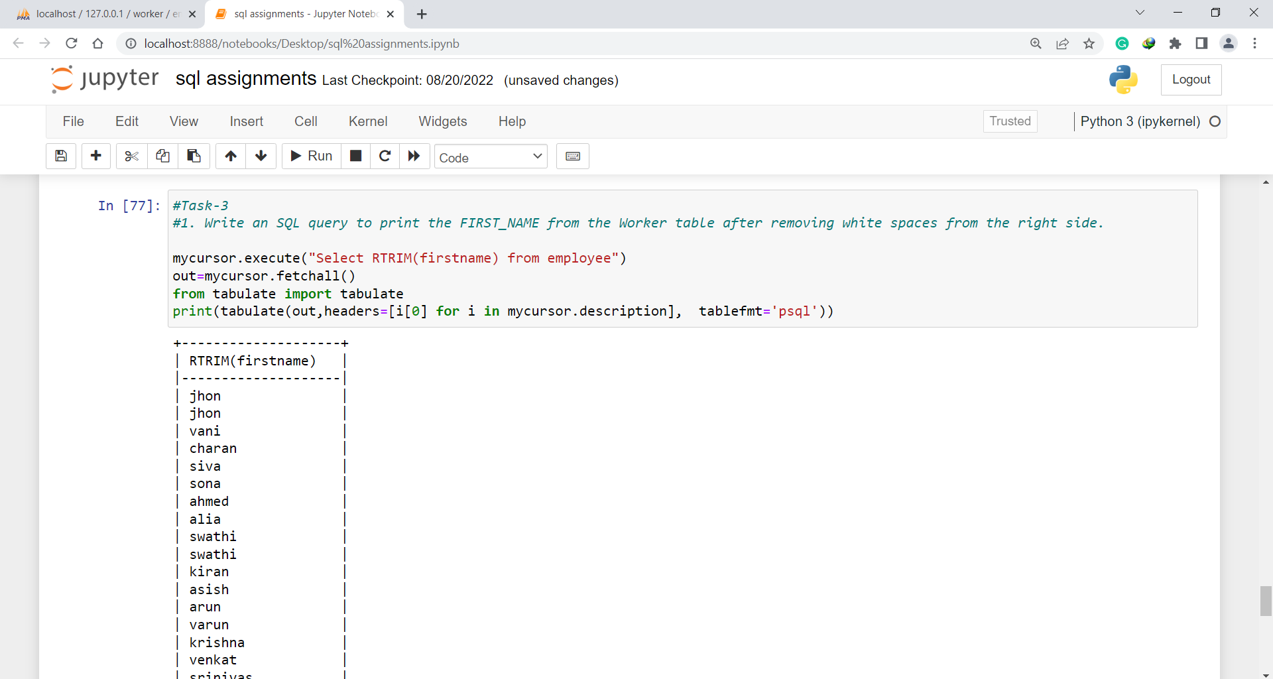

1. Write an SQL query that fetches the unique values of DEPARTMENT from the Worker table and prints its length.

Ans. Select distinct length(DEPARTMENT), department from employee;

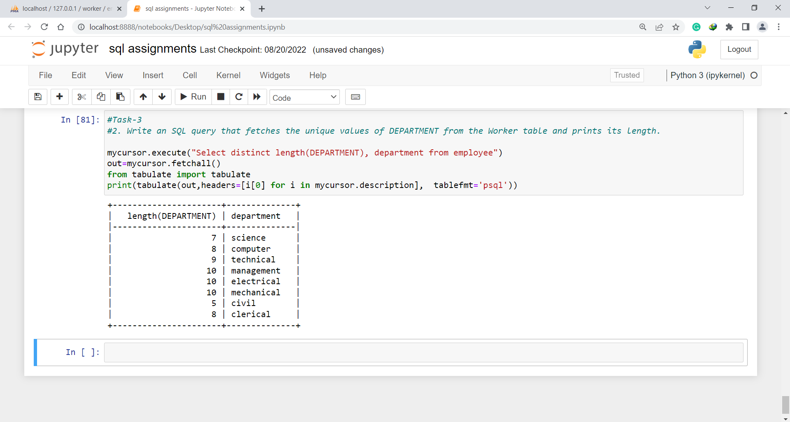

1. Write an SQL query to fetch nth max salaries from a table.

Ans. SELECT DISTINCT(salary),firstname FROM employee ORDER BY salary DESC LIMIT 0,5;

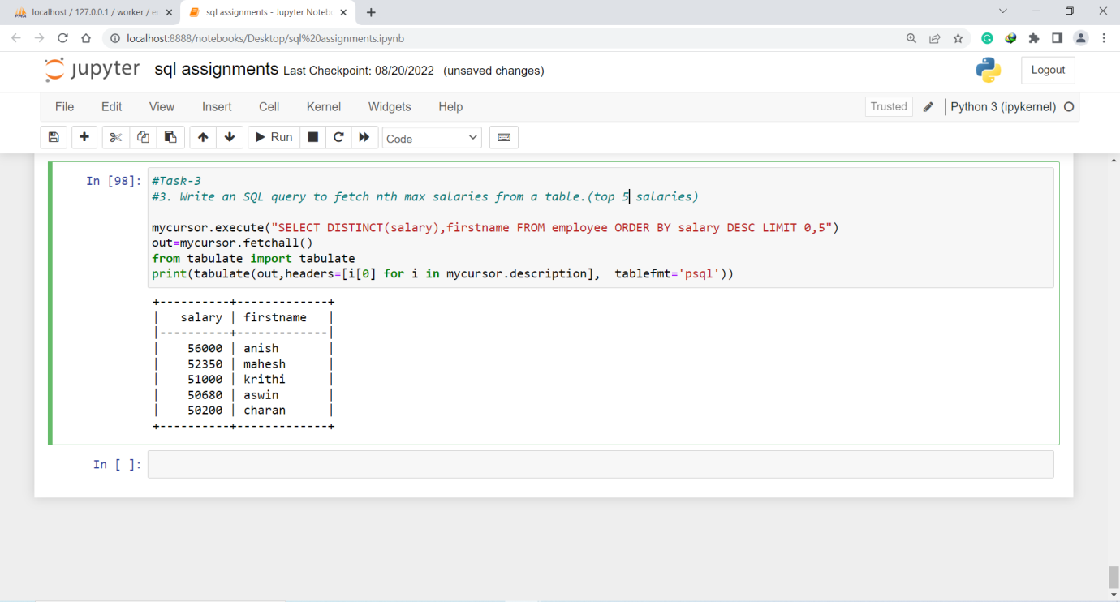

**Task-4**

1. Write an SQL query to print the FIRST_NAME from the Worker table after replacing ‘a’ with ‘A’.

Ans. Select REPLACE(firstname,'a','A') from employee;

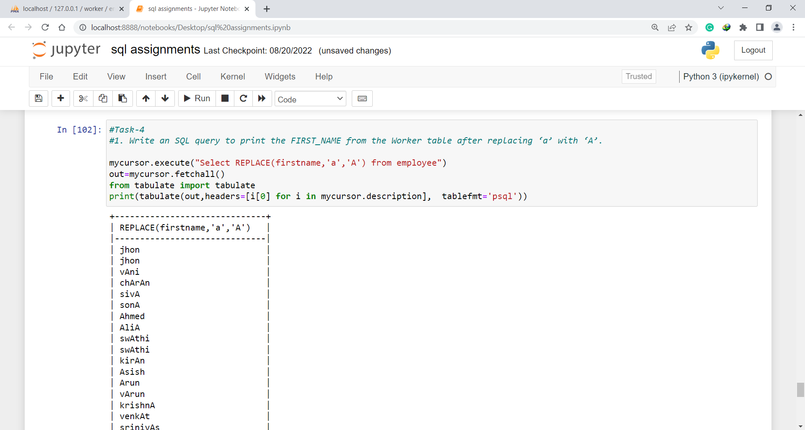

1. Write an SQL query to print all Worker details from the Worker table order FIRST_NAME Ascending and DEPARTMENT Descending.

Ans. Select * from employee order by FIRSTNAME asc,DEPARTMENT desc;

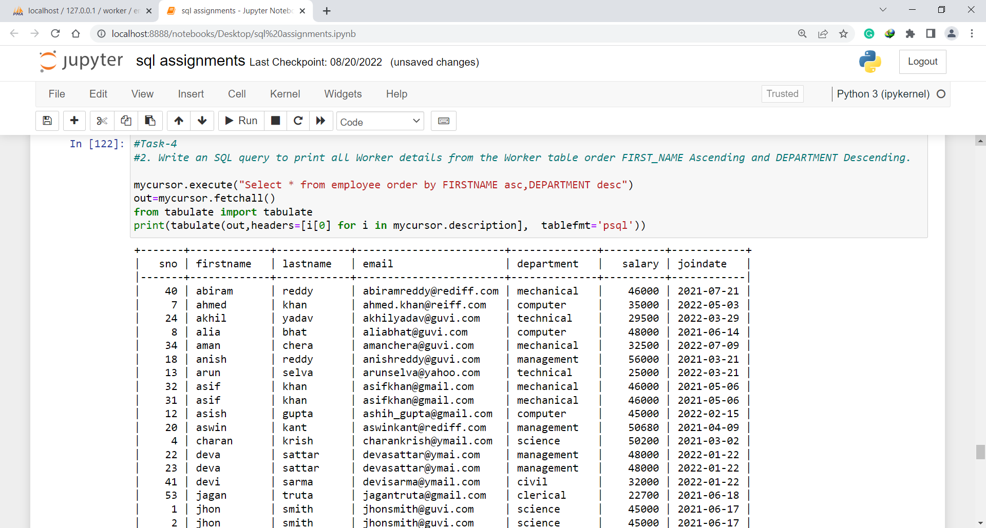

1. Write an SQL query to fetch the names of workers who earn the highest salary.

Ans.SELECT FIRSTNAME, SALARY from employee WHERE SALARY=(SELECT max(SALARY) from employee);

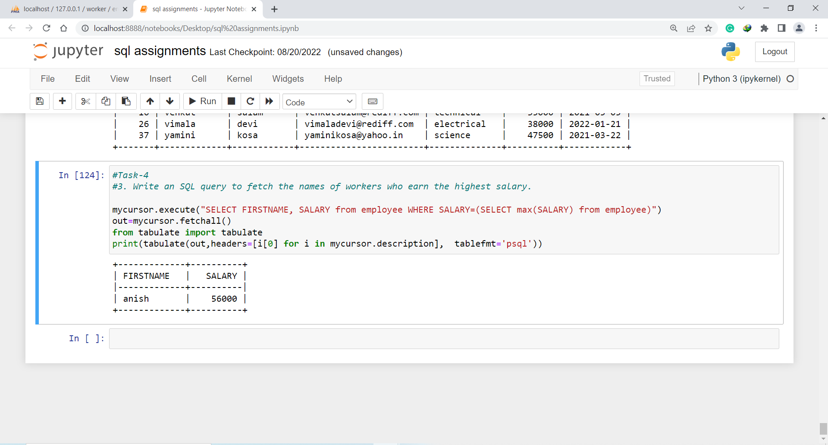

**Task-5**

1. Write an SQL query to print details of workers excluding first names, “Ramesh” and “Santhosh” from the Worker table.

Ans. Select * from employee where FIRSTNAME not in ('Ramesh','suresh');

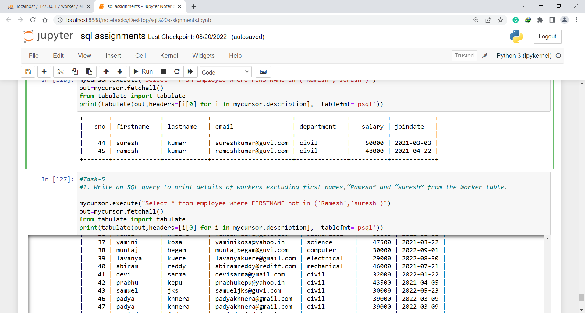

1. Write an SQL query to print details of the Workers whose FIRST_NAME ends with ‘h’ and contains six alphabets.

Ans. Select * from employee where FIRSTNAME like '_____h';

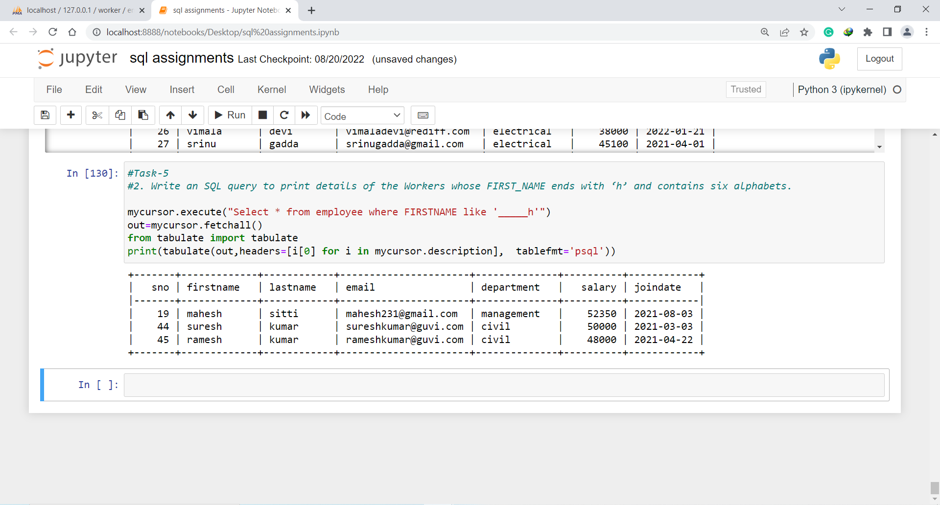

**Task-6**

1. Write an SQL query to print details of the Workers who have joined in March ’2021.

Ans. Select * from employee where year(JOINDATE) = 2021 and month(JOINDATE) = 3;

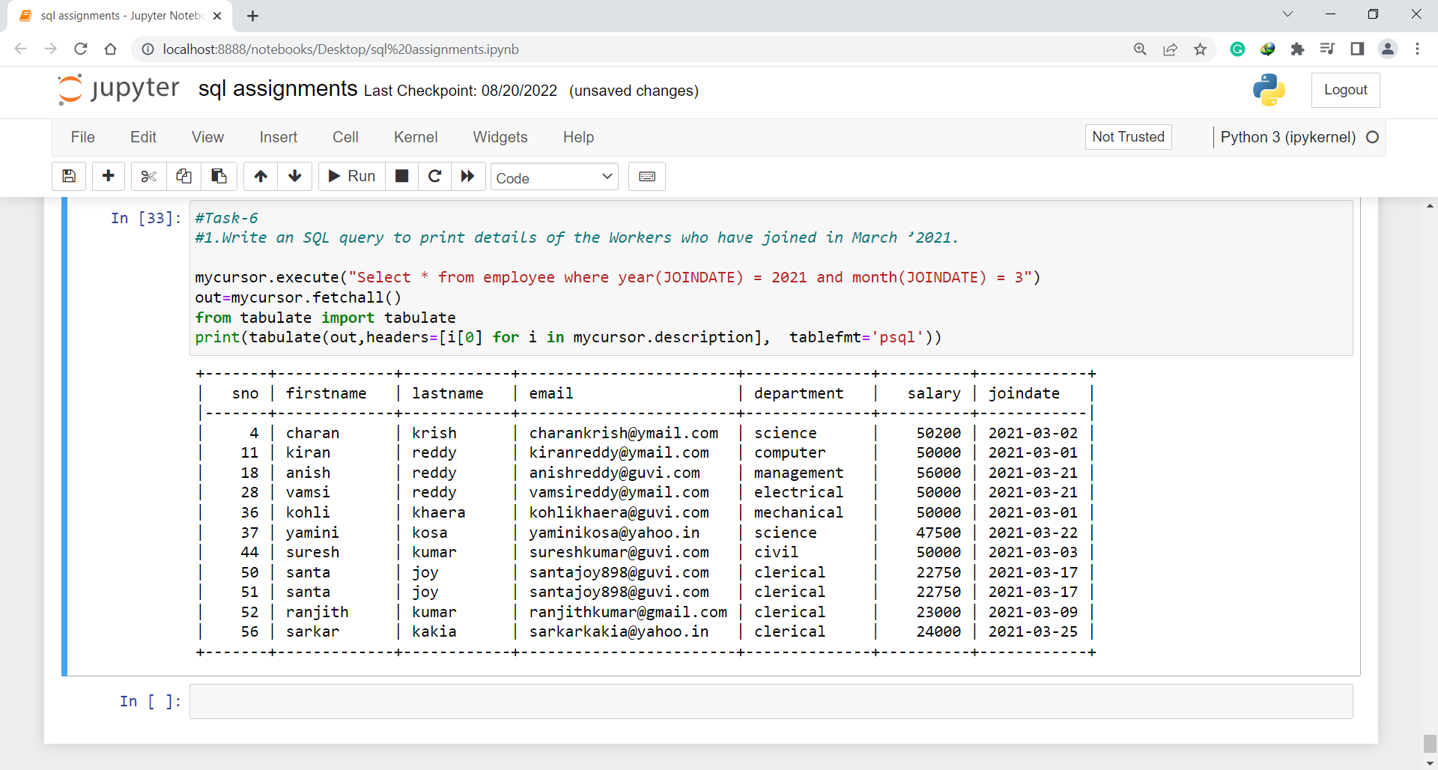

1. Write an SQL query to fetch duplicates that have matching data in some fields of a table.

Ans. SELECT * , COUNT(*) FROM employee GROUP BY firstname HAVING COUNT(*) > 1;

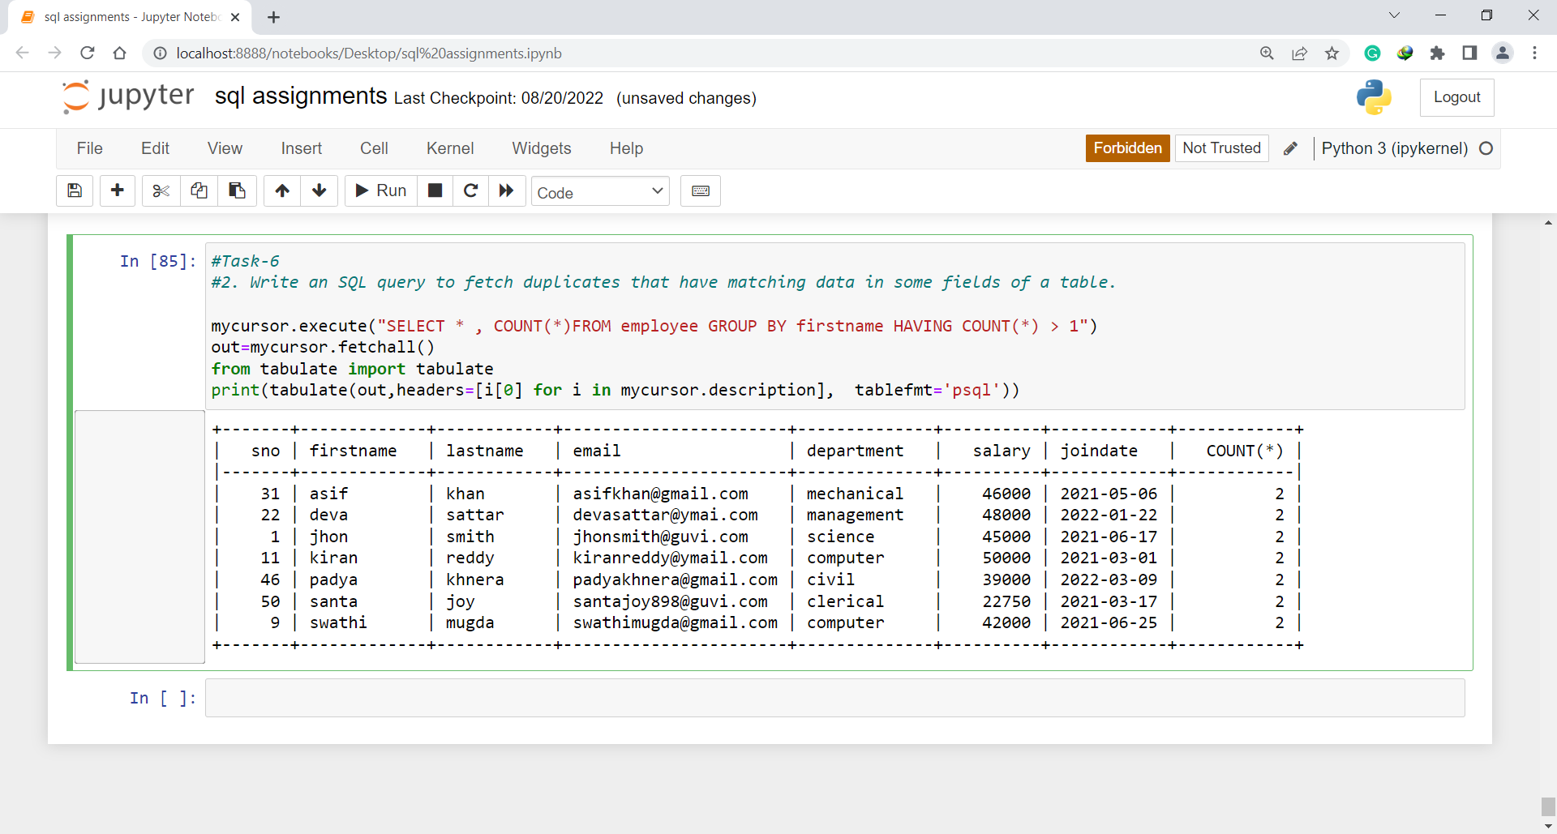

1. How to remove duplicate rows from the Employees table.

Ans. DELETE t1 FROM employee t1

INNER JOIN employee t2

WHERE

t1.firstname < t2.firstname AND

t1.lastname = t2.lastname;

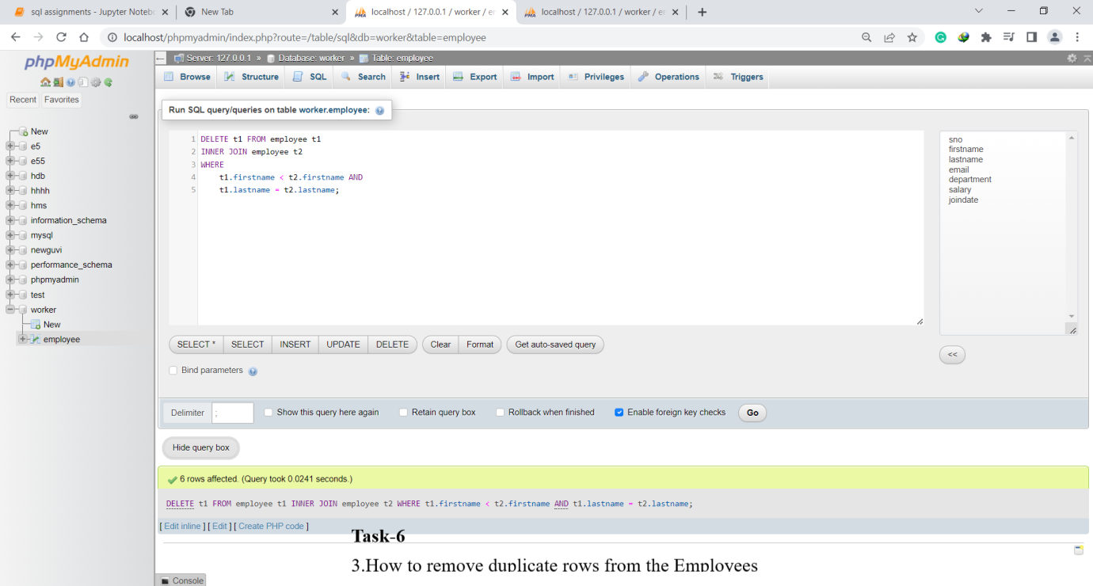

**Task-7**

1. Write an SQL query to show only odd rows from a table.

Ans. SELECT * FROM employee WHERE MOD (sno, 2) <> 0;

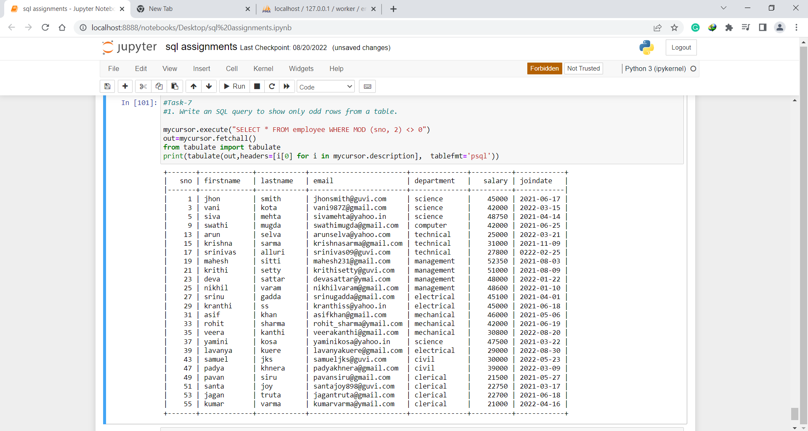

1. Write an SQL query to clone a new table from another table.

Ans. CREATE TABLE employeenew LIKE employee;

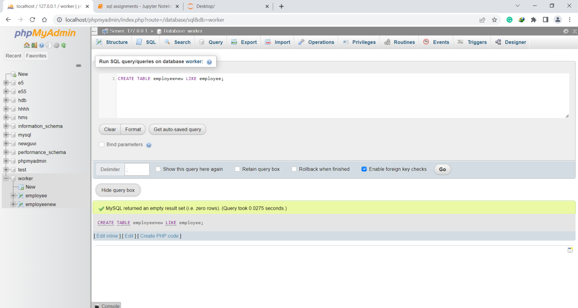

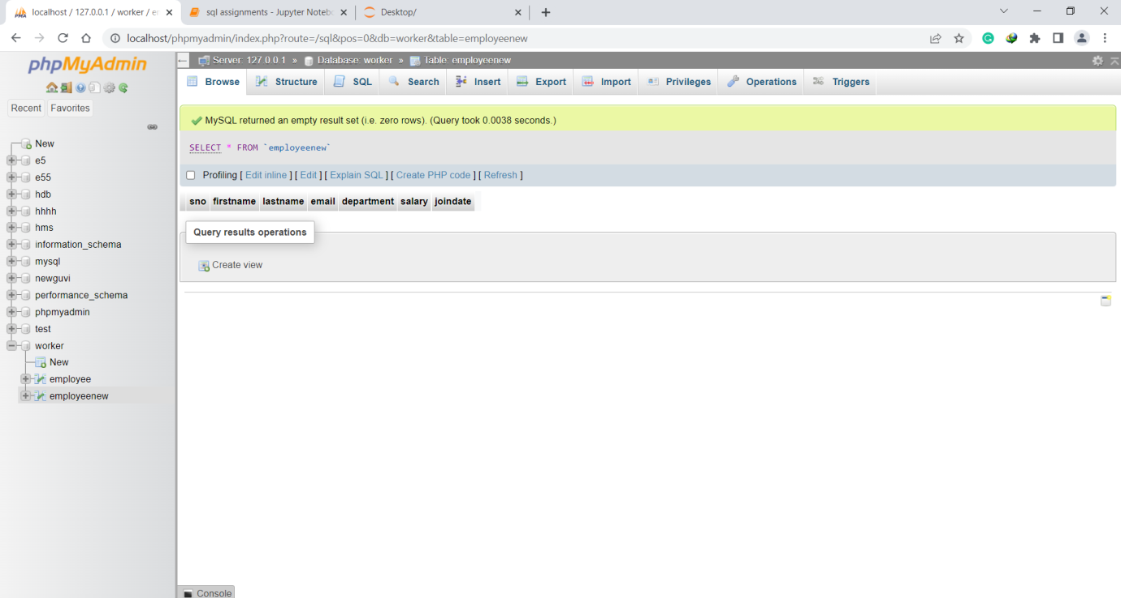

(To insert same values of employee table into clone table employeenew.)

INSERT INTO `employeenew`(`sno`, `firstname`, `lastname`, `email`, `department`, `salary`, `joindate`) SELECT `sno`, `firstname`, `lastname`, `email`, `department`, `salary`, `joindate` FROM `employee`’

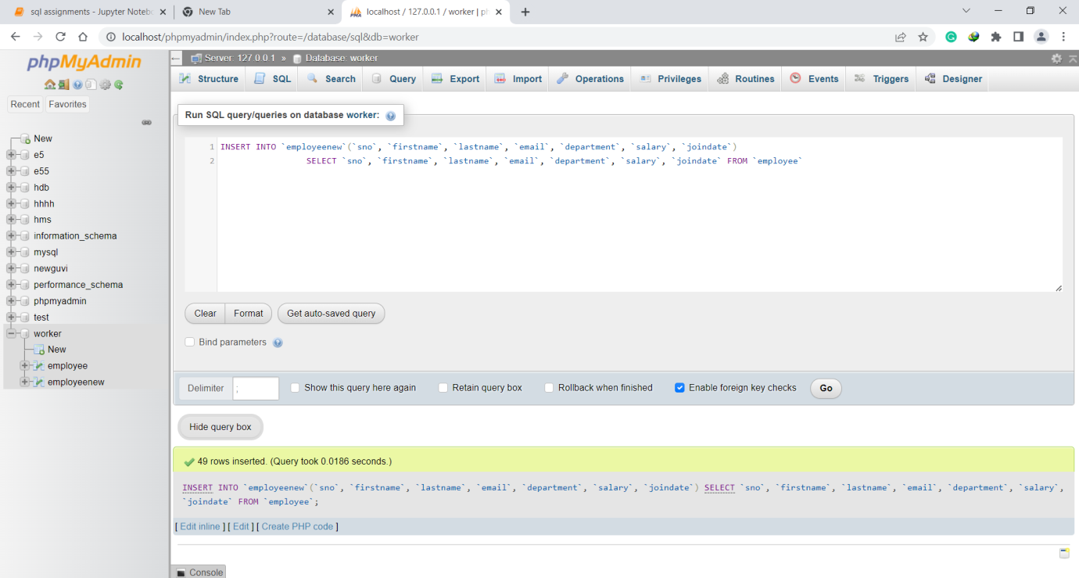

**Task-8**

1. Write an SQL query to fetch intersecting records of two tables.

Ans. SELECT employee.sno, employee.lastname, employeenew.sno, employee.lastname FROM employee inner JOIN employeenew ON employeenew.lastname = employee.lastname;

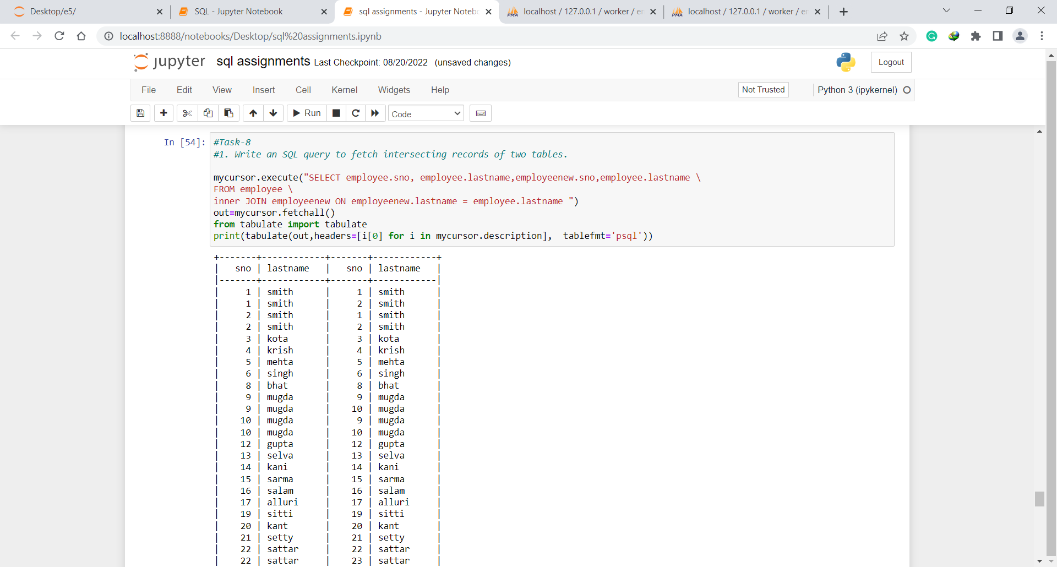

1. Write an SQL query to show records from one table that another table does not have.

Ans. SELECT sno, firstname, lastname, department, salary, joindate

FROM employee

WHERE NOT EXISTS

(SELECT * FROM employeenew

WHERE employeenew.firstname = employee.firstname);

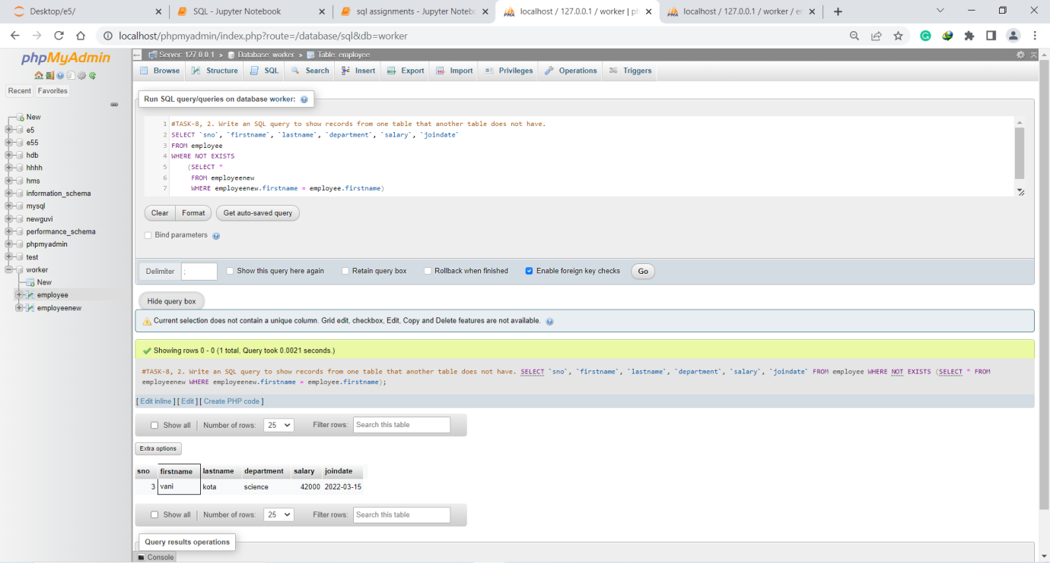

**Task-9**

1. Write an SQL query to show the top n (say 15) records of a table.

Ans. SELECT * FROM employee ORDER BY Salary DESC LIMIT 15;

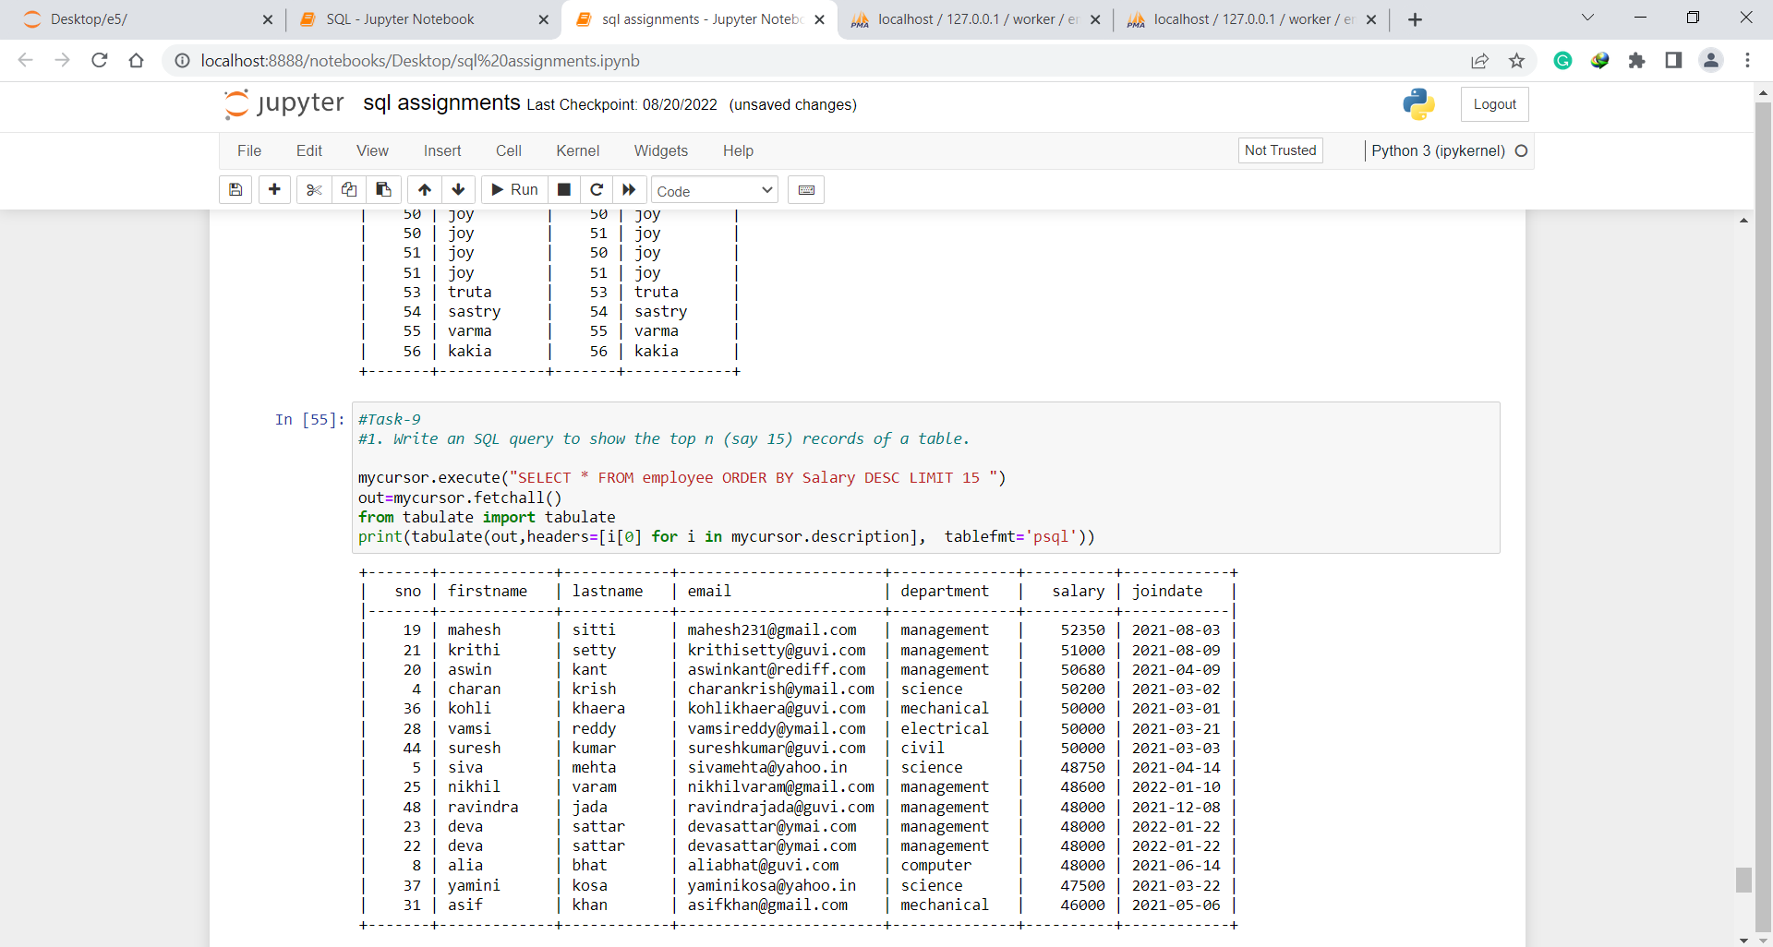

1. Write an SQL query to determine the nth (say n=10) highest salary from a table.

Ans. SELECT DISTINCT salary FROM Employee ORDER BY salary DESC limit 10,1;

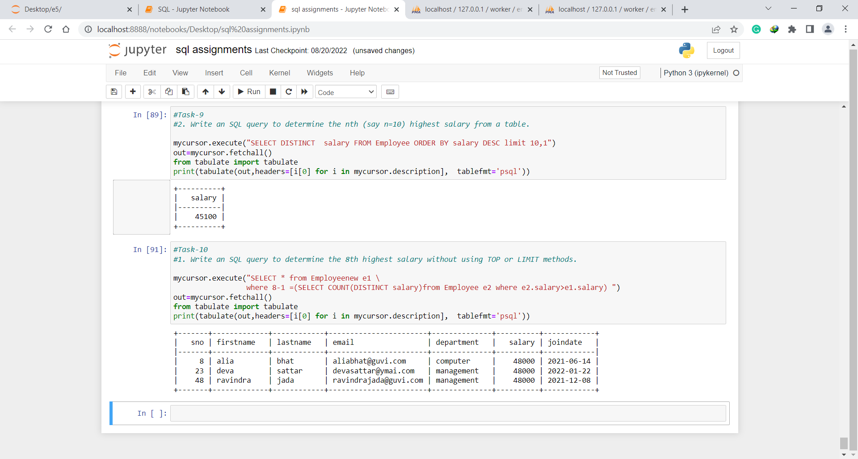

**Task-10**

1. Write an SQL query to determine the 8th highest salary without using TOP or LIMIT methods.

Ans. SELECT * from Employeenew e1 where 8-1 =(SELECT COUNT(DISTINCT salary)from Employee e2 where e2.salary>e1.salary);



1. Write an SQL query to fetch the list of employees with the same salary.

Ans. Select distinct e.SNO, e.FIRSTNAME, e.Salary from employeenew e, employeenew e1 where e.Salary = e1.Salary and e.sno != e1.sno;

